Professional Development Planning Guidance and Template

The table overleaf will help you collate the activities you have completed throughout your academic journey.

Use the Vitae Researcher Development Framework Graphic (below) and visit the Vitae Website for guidance of the skill domains for researchers.

You may want to also use your Summary of Personal and Professional Development Activity while completing this document.

When completing the table, look to see if you are focusing on one skill area more than another and ask yourself why this may be. Identify gaps and opportunities to develop skills in different areas. You can then approach your supervisor, research culture group or book a 1-2-1 with one of The Graduate School consultants.
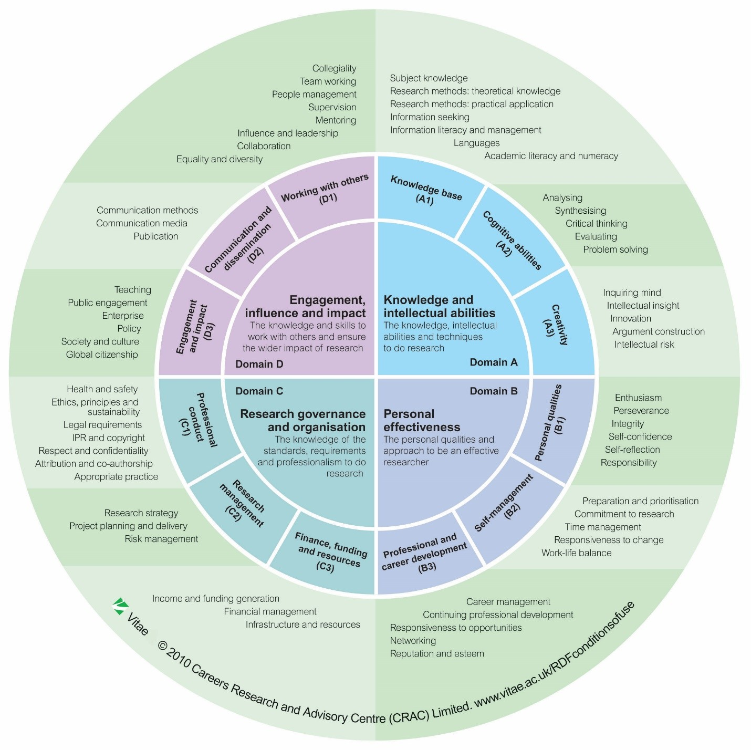
Activity completed | Type of Activity | Length | Skills Domain | Notes

Number of skills in each domain:

Domain A | Domain B | Domain C | Domain D

Areas to focus on:

Type of activity | Domain | Time scale
Notes

Type of activity | Domain | Time scale
Notes

